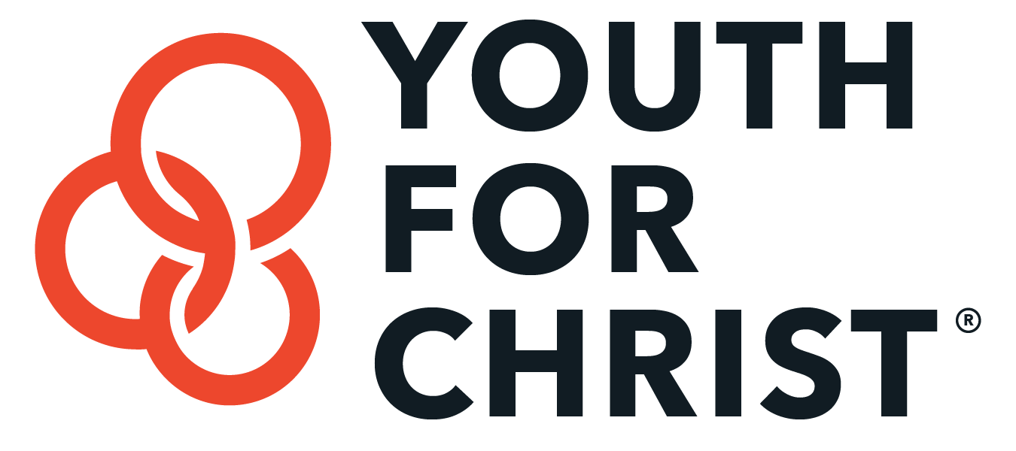
Sabbatical

In the Marketplace

A comment we often hear is… “Universities and churches have sabbaticals, but do any corporations have a sabbatical policy?” If you go online you will find a lot of interesting information about how companies are developing sabbatical programs or already have them in place. Just some examples are:

Business Excellence Magazine, June 7, 2011 “Sustainability: Corporate sabbaticals”
HUFF POST, August 26, 2013 “Why Clif Car offers Sabbaticals and other unconventional work Perks”
CNNMoney, January 3, 2011, “Should companies offer sabbaticals?”
FORTUNE magazine’s “2012 100 Best Companies to Work for”, Nearly 25% of the companies on that list offer fully paid sabbaticals.

A few companies you might know of that have a sabbatical program for their team:
- American Express
- Blue Cross Blue Shield
- Charles Schwab
- Ebay
- General Mills
- Goldman Sachs
- Hallmark
- Intel
- McDonalds
- Newsweek
- Nike
- Patagonia
- Random House
- REI
- Timberland
- Procter & Gamble

These big companies recognize the value of sabbaticals to maintain a healthy team and sustainability.

