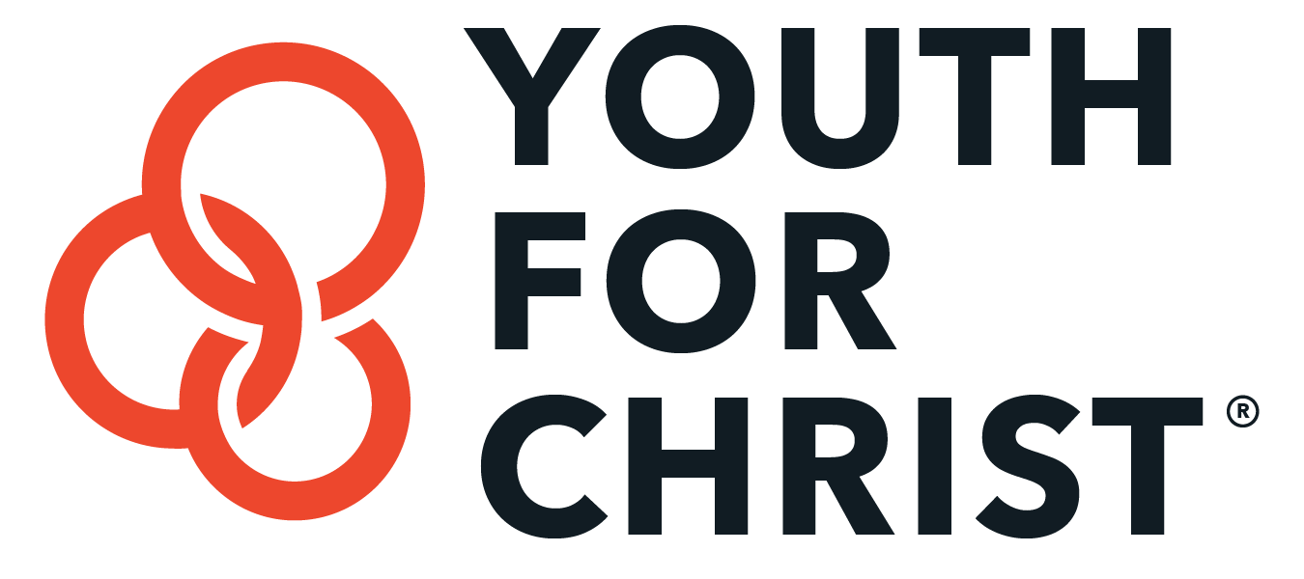
Sabbatical

Retreats & Counseling
Centers

Retreats & Counseling Centers
Sonscape - Counseling intensives in group setting for pastors and ministry personnel in Colorado, Tennessee, and Georgia - Contact
Shepherd’s Heart - One on one counseling intensives for full-time Christian workers in Colorado and Michigan - Contact
Potter’s Inn - Counseling intensives and week-long retreats in Colorado - Contact
Alongside Ministries - 2-3 week intensive counseling sessions - Contact
Caring for the Heart – Marriage counseling sessions - Contact
Hilltop Renewal Center – Private retreats, spiritual guidance available - Contact
A'nesis Christian Retreats & Counseling Sabbaticals – Exclusively for women in Colorado and Tennessee - Contact

Monasteries and Convents
Marytown Retreat House – Private Retreats in Illinois - Contact
St. Meinrad’s Archabby – Private Retreats in Indiana - Contact
Abby of Gethsemani – Private Retreats in Kentucky - Contact

Independent Christian Counselors
Dr. Michael Cuzak – Private practice counseling in Colorado - Contact
Dr. Ron Rickner – Annual YFC Institute speaker, private practice in Florida - Contact

